“He is not here, for he has risen, just like He said.”

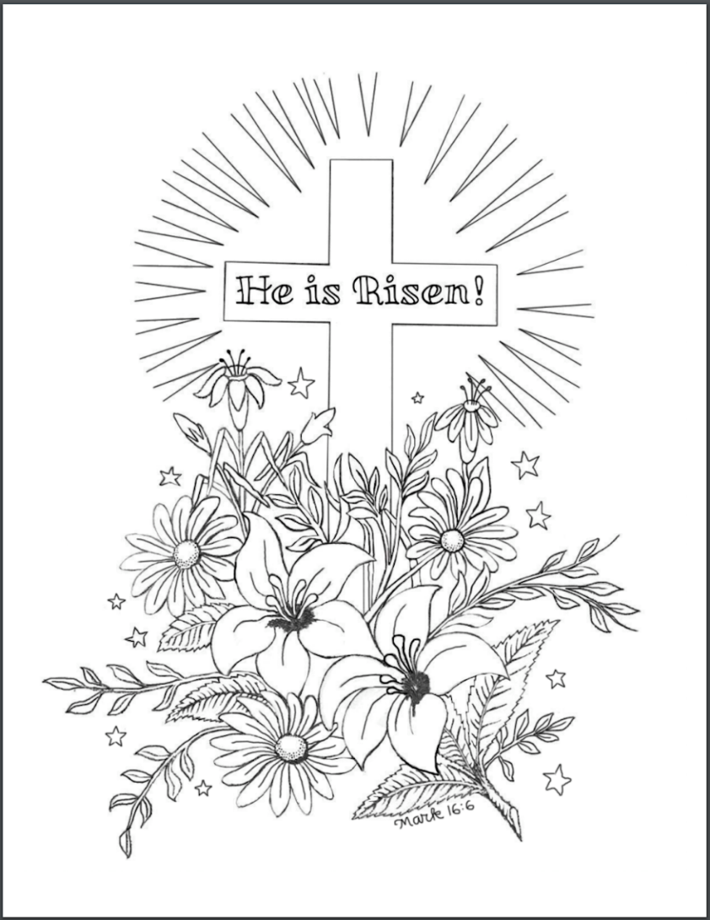

His FIRST Steps Led Outside His Tomb

Easter Sunday Celebration
April 9, 2023

Welcome! We are glad you are here! In worship, we gather before the almighty God to offer him the praise that is due his name and to be fed by his life-giving Word. This service folder will guide you through our path of worship. If you have any questions, please don’t hesitate to ask an usher or the person sitting next to you. God bless your time in this house of God.

Bathrooms are located in the fellowship hall. A changing table is located in the women’s bathroom.

A worship monitor is to the right as you exit. We encourage children of all ages to participate in our worship. Please bring them into the service. We have a nursery room with toys, books, and other items that you can use with your child.
Before you leave, please sign our guest register. Located on the lectern in the entryway.

The Resurrection of Our Lord
Call to Worship

M: Alleluia! Christ is risen!
C: He is risen indeed! Alleluia!

OPENING HYMN This Joyful Eastertide (CW 160)
AN EASTER DIALOGUE

M: “Christ is risen!
C: He is risen indeed!”

M: Let us rejoice and give thanks to God for the victory our Lord Jesus Christ won by his death and
resurrection. Christ died for all, that those who
live should no longer live for themselves but for
him who died for them and was raised again.
2Corinthians 5:15
C: I will not die, but live, and will proclaim what the LORD has done. Psalm 118:17

M: If anyone is in Christ, he is a new creation, the old has gone, the new has come!
2Corinthians 5:17
C: I will not die, but live, and will proclaim what the LORD has done.

M: For you were once darkness, but now you are light in the Lord. Ephesians 5:8
C: I will not die, but live, and will proclaim what the LORD has done.

1 This is known as the Paschal Greeting, one of the oldest and most wide-spread traditions in the Christian church. Throughout the weeks of the Easter Season, whenever the minister says to the people “Christ is risen!” they automatically respond, loudly and boldly, “He is risen indeed!”
M: God invites us to come into his presence and worship him with humble and repentant hearts. Therefore, let us acknowledge our sins and ask him to forgive us.
C: Merciful Father in heaven, I am altogether sinful from birth. In countless ways I have sinned against you and do not deserve to be called your child. But trusting in Jesus, my Savior, I pray: Have mercy on me according to your unfailing love. Cleanse me from my sin, and take away my guilt.
M: God, our heavenly Father, has been merciful t0 us and has given his only Son to be the atoning sacrifice for our sins. Christ has died. Christ has risen. Christ will come again. You are at peace with God through Christ.
Therefore, as a called servant of Christ and by his authority, I forgive you all your sins in the name of the Father and of the Son (†) and of the Holy Spirit.
C: Amen.
M: With joy of forgiveness, let us praise the Lord.
I Know that My Redeemer Lives CW 152 vs.1-4
C: (All) I know that my Redeemer lives;
What comfort this sweet sentence gives!
He lives, he lives, who once was dead.
He lives, my everliving Head!
(Men) He lives triumphant from the grave;
He lives eternally to save.
He lives all-glorious in the sky;
He lives exalted there on high.
(Women) He lives to bless me with his love;
He lives to plead for me above.
He lives my hungry soul to feed;
He lives to help in time of need.
(All) He lives to grant me rich supply;
He lives to guide me with his eye.
He lives to comfort me when faint;
He lives to hear my soul’s complaint.

PRAYER OF THE DAY

M: Let us pray. Almighty God, by the glorious resurrection of your Son Jesus Christ you conquered death and opened the gate to eternal life. Grant that we, who have been raised with him through baptism, may walk in the newness of life and ever rejoice in the hope of sharing his glory; through Jesus Christ our Lord, to whom, with you and the Holy Spirit be dominion and praise now and forever.
C: Amen.

FIRST LESSON Jonah 2:2-9 (pg. 916)

2He said: "In my distress I called to the Lord , and he answered me. From the depths of the grave I called for help, and you listened to my cry. 3You hurled me into the deep, into the very heart of the seas, and the currents swirled about me; all your waves and breakers swept over me. 4 I said, 'I have been banished from your sight; yet I will look again toward your holy temple.' 5The engulfing waters threatened me, the deep surrounded me; seaweed was wrapped around my head. 6To the roots of the mountains I sank down; the earth beneath barred me in forever. But you brought my life up from the pit, O Lord my God. 7 "When my life was ebbing away, I remembered you, Lord , and my prayer rose to you, to your holy temple. 8 "Those who cling to worthless idols forfeit the grace that could be theirs. 9But I, with a song of thanksgiving, will sacrifice to you. What I have vowed I will make good. Salvation comes from the Lord ."

M: This is the Word of the Lord.
C: Thanks be to God!

HYMN Morning Breaks upon the Tomb CW 159

SECOND LESSON 1Corinthians 15:1-11
1Now, brothers, I want to remind you of the gospel I preached to you, which you received and on which you have taken your stand. 2By this gospel you are saved, if you hold firmly to the word I preached to you. Otherwise, you have believed in vain. 3For what I received I passed on to you as of first importance : that Christ died for our sins according to the Scriptures, 4 that he was buried, that he was raised on the third day according to the Scriptures, 5and that he appeared to Peter, and then to the Twelve. 6After that, he appeared to more than five hundred of the brothers at the same time, most of whom are still living, though some have fallen asleep. 7Then he appeared to James, then to all the apostles, 8and last of all he appeared to me also, as to one abnormally born. 9For I am the least of the apostles and do not even deserve to be called an apostle, because I persecuted the church of God. 10But by the grace of God I am what I am, and his grace to me was not without effect. No, I worked harder than all of them--yet not I, but the grace of God that was with me. 11Whether, then, it was I or they, this is what we preach, and this is what you believed.

M: This is the Word of the Lord.
C: Thanks be to God!

HYMN O Sons and Daughters of the King CW 165
Vs. 1, 3, 8, 9

GOSPEL Matthew 28:1-10
1After the Sabbath, at dawn on the first day of the week, Mary Magdalene and the other Mary went to look at the tomb. 2There was a violent earthquake, for an angel of the Lord came down from heaven and, going to the tomb, rolled back the stone and sat on it. 3His appearance was like lightning, and his clothes were white as snow. 4The guards were so afraid of him that they shook and became like dead men. 5The angel said to the women, "Do not be afraid, for I know that you are looking for Jesus, who was crucified. 6He is not here; he has risen, just as he said. Come and see the place where he lay. 7Then go quickly and tell his disciples: 'He has risen from the dead and is going ahead of you into Galilee. There you will see him.
Now I have told you." 8So the women hurried away from the tomb, afraid yet filled with joy, and ran to tell his disciples. 9Suddenly Jesus met them. "Greetings," he said. They came to him, clasped his feet and worshiped him. 10Then Jesus said to them, "Do not be afraid. Go and tell my brothers to go to Galilee; there they will see me."

M: This is the Gospel of the Lord.
C: Praise be to you, O Christ!

STATEMENT OF FAITH Apostles’ Creed

C: I believe in God, the Father almighty, maker of heaven and earth.

I believe in Jesus Christ, His only Son, our Lord, who was conceived by the Holy Spirit, born of the virgin Mary, suffered under Pontius Pilate, was crucified, died, and was buried.

He descended into hell. The third day he rose again from the dead. He ascended into heaven and is seated at the right hand of God the Father almighty. From there He will come to judge the living and the dead.

I believe in the Holy Spirit, the holy Christian Church, the communion of saints, the forgiveness of sins, the resurrection of the body, and the life everlasting. Amen.

HYMN OF THE DAY Jesus Christ Is Risen Today CW 157

SERMON His FIRST steps Led Outside His Tomb John 20:11-18

OFFERING
We joyfully respond to our Shepherd’s loving care by praising him with all we are and all we have. Bringing an offering is an act of trust in God’s promises to provide and an acknowledgement that “my cup overflows.” A joyful and generous offering is always a wonderful way to show Jesus that he is our greatest treasure and worthy of our praise. May God be praised through our offerings!

PRAYER OF THE CHURCH
M: Lord of life, we praise you for Christ’s victory over death and the peace which is ours through your saving work. Keep in faith all of us whom you have baptized into the death and resurrection of Jesus. Drive sin out of all of our hearts. Strengthen us to resist the devil’s temptations. Fill us with Easter life so that the world can see by our lives that you have given us life that lasts forever. In the name of our risen Lord,
C: hear our prayer and give us life.

M: Lord of life, through your angel you invited the women at Jesus’ empty tomb to tell Peter and the disciples about his resurrection. Give us hearts so filled with thanks that we do not keep the Good News to ourselves but tell it to the people in our lives and joyfully support the proclamation of the Gospel all over the world. In the name of our risen Lord,
C: hear our prayer and give us life.

M: Lord of life, give your care and courage to pastors, missionaries, and teachers of your Word around the world. Wherever the message of your Son’s death and resurrection is proclaimed, create faith in the hearts of unbelievers and bring them from death to life. In the name of our risen Lord,
C: hear our prayer and give us life.

M: Lord of life, you promise to wipe away tears from all faces. We beg you to be with the sick, the injured, the aged, and everyone in need. (Especially we pray for…). Give them the peace that comes from having resurrection life in Jesus, and, if you know it to be best, give them healing also. In the name of our risen Lord,
C: hear our prayer and give us life.

M: Lord of life, we remember with thanksgiving and love those who have fallen asleep in Jesus and now await the resurrection of all flesh, (especially….). Keep us as you kept them all that all of us, as your faith-filled people, may live forever in glory. In the name of our risen Lord,
C: hear our prayer and give us life. Amen.

LORD’S PRAYER

C: Our Father, who art in heaven, hallowed be thy name, thy kingdom come, thy will be done on earth as it is in heaven. Give us this day our daily bread; and forgive us our trespasses, as we forgive those who trespass against us; and lead us not into temptation, but deliver us from evil. For thine is the kingdom and the power and the glory forever and ever. Amen.

HYMN In Christ Alone On Screen

PRAYER

M: We give you thanks, O Lord, for the feast of victory which is ours through faith in Christ Jesus. Through your Word you have fed our faith, nourished our hope, and strengthened our love. By your spirit help us to live as your holy people until that day when you will receive us as your guests at the feast of glory in heaven, through your Son, Jesus Christ, who lives and reigns with you and the Holy Spirit, one God, now and forever.

C: Amen.

BLESSING

Brothers and sisters, go in peace. Live in harmony with one another. Serve the Lord with gladness.
The Lord bless you and keep you.
The Lord make his face shine on you and be gracious to you.
The Lord look on you with favor (†) and give you peace.
C: Amen.
CLOSING HYMN I Know that My Redeemer Lives CW152 vs. 5-8
C: (All) He lives to silence all my fears;
He lives to wipe away my tears.
He lives to calm my troubled heart;
He lives, all blessings to impart.

(Men) He lives, my kind, wise, heav'nly friend;
He lives and loves me to the end.
He lives, and while he lives I'll sing;
He lives, my Prophet, Priest, and King.

(Women) He lives and grants me daily breath;
He lives, and I shall conquer death.
He lives my mansion to prepare;
He lives to bring me safely there.

(All)He lives, all glory to his name!
He lives, my Jesus, still the same.
Oh, the sweet joy this sentence gives:
"I know that my Redeemer lives!"

Martin Luther on the Resurrection of Christ

“It was not necessary for Christ to die for himself, because he was born without sin and the devil had no claim on him. Moreover, he was Lord over devil and death, so that the devil did not dare to attack him. Christ might well have defied the devil and challenged him to touch one little hair of his head. …No, we must view Christ in this light, that this dying and rising again were for your benefit and mine. As he died and lay under the sod as you and I must die and be buried, thus he also rose again for our sakes and made an exchange with us; as he was brought into death through us, we shall be restored from death to life through him. For by his death he has devoured our death, so that we all will also arise and live as he arose and lives…We must not let death and other misfortune, distress, misery, terrify us so. Nor must we regard what the world has and can do, but balance this against what we are and have in Christ. For our confidence is built entirely on the fact that he has arisen and that we have life with him already and are no longer in the power of death. Therefore let the world be bad and foolish, boasting of and relying on its money and goods; and let the devil rage with his poisonous darts in our conscience; and let him afflict us with all sorts of trouble – against all this our one defiant boast shall be that Christ is our Firstfruits (1Corinthians 15:20), that he has initiated the resurrection, that he has burst through the devil’s kingdom, through hell and death, that he no longer dies or sleeps but rules and reigns up above eternally, in order to rescue us, too, from this prison and death.” (From Luther’s Works vol. 28:109-111)

13009 N. Elderberry Ct.
Lodi, CA 95242
www.christlodi.org
209-368-6250
WELCOME TO CHRIST EV. LUTHERAN CHURCH!
We preach a message of forgiveness, hope and peace
through the death and resurrection of Jesus Christ.
Families and individuals of all ages will find opportunities
both to grow and to serve.

Our mission statement:
Look what Christ is doing!
He binds us together in fellowship
He gathers us in for worship
He builds us up for service
He sends us out with the gospel

“Now you are the body of Christ,
and each one of you is a part of it.”
(1 Corinthians 12:27)

